**Type the Title Here**

*Type the class here*

*Type your name(s) here*

*Type the date here*

Introduction

Type the introduction here. This should be 4 - 5 sentences. What is the specific problem that will be addressed? Have you built upon previous work or existing theories? Why is this work important? What can the reader expect to learn by reading your report?

Procedure

Type the procedure here. This should be at most ¾ page. You should generalize the procedure used to include the basic steps, but you do not need to include every detail. The reader should gain an understanding of how you performed your analysis. Include where fixtures and loads were applied and include a figure. Also include any assumptions that apply to your model.

Results

Insert the results here, but do not discuss them or draw any conclusions. Include figures and tables. A table comparing your different designs is required as well as the theoretical results. Any figures produced from SOLIDWORKS must include your name. Be sure each is clear enough to stand alone, with 1 – 2 sentences of explanation. Include a table caption at the top of the table, and a figure caption at the bottom of the figure. The caption should include a number and a word description. Any graphs should NOT have titles since they have captions!

Be aware that your tables and figures should illustrate DIFFERENT ideas; they should not contain the same data. Do NOT include large tables of raw data. This section should be a SAMPLE of your work, used to illustrate the points of your discussion. Be sure to follow proper plot rules. Be sure your graphs can be easily read.

Table 1. Example of a properly formatted table.

|  |  |  |  |
| --- | --- | --- | --- |
| **Section** | **Instructor** | **E-mail** | **Time** |
| -030 | Dr. Stephan | drstephan | M 8:00 – 9:55 |
| -031 | Dr. Sill | drsill | M 12:20 – 2:15 |
| -032 | Dr. Ohland | drohland | W 8:00 – 9:55 |
| -033 | Dr. Park | drpark | F 12:20 – 2:15 |

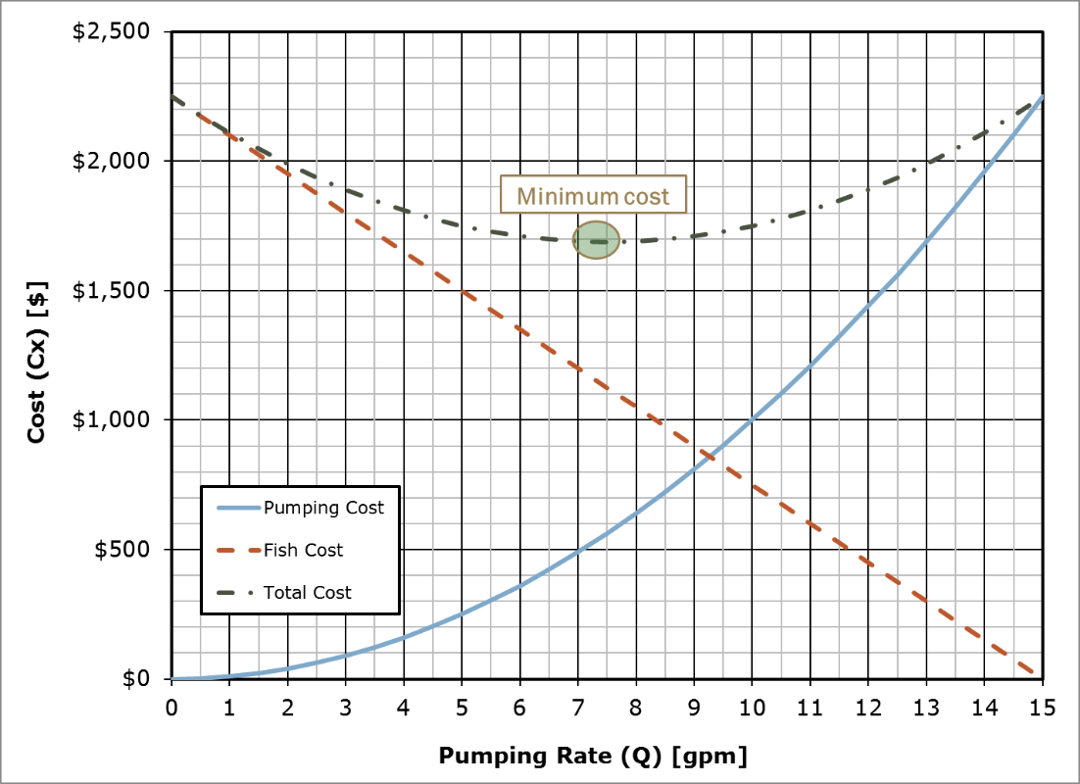

Figure 1. Example of a properly formatted figure.

Discussion

Talk about your results here. Refer to the table and figure shown in results by name (As shown in Figure 1…). This can be up to 2 page maximum. Refer to the table and figure shown in results by name. Be sure to include the items specifically requested in the original project description. Remember to report facts and justify your choices – show you have actually THOUGHT about the results and can explain them in a meaningful way.

You should be discussing the differences between your various designs and specifically why/how you chose your final design. You should also be discussing how your SOLIDWORKS results compare to your theoretical results and explain why any difference is occurring.

Summary

What is the final conclusion? As your boss, I may only have time to read the introduction (what is the problem) and the summary (what is the answer) and glance at the results (how did you get the answer) before I head to a big meeting. This should be 4 – 5 sentences long, and answer the initial questions asked in the introduction and summarize any important findings. Do not include any new information here.